[Date]

LISTE DES PAGES EFFECTIVES
Chapitre | Page | N°d’édition | Date d’édition | N°de révision | Date de révision
LPE | 1-2 | 01 | 15/07/2020 | 00 | 15/07/2020
ER | 3 | 01 | 15/07/2020 | 00 | 15/07/2020
LA | 4 | 01 | 15/07/2020 | 00 | 15/07/2020
LR | 5 | 01 | 15/07/2020 | 00 | 15/07/2020
TM | 6-8 | 01 | 15/07/2020 | 00 | 15/07/2020
TERMINOLOGY | 9 | 01 | 15/07/2020 | 00 | 15/07/2020
SECTION A — TECHNICAL REQUIREMENTS | 10 | 01 | 15/07/2020 | 00 | 15/07/2020
Subpart A - General | 11 | 01 | 15/07/2020 | 00 | 15/07/2020
Subpart B – Type-certificates | 12 | 01 | 15/07/2020 | 00 | 15/07/2020
Subpart C – Not applicable | 13 | 01 | 15/07/2020 | 00 | 15/07/2020
Subpart D – Changes to type-certificates | 14
Subpart E – Supplemental type-certificates | 15 | 01 | 15/07/2020 | 00 | 15/07/2020
Subpart F – Production without production organisation approval | 16 | 01 | 15/07/2020 | 00 | 15/07/2020
Subpart G – Production organisation approval for products, parts and appliances | 17 | 01 | 15/07/2020 | 00 | 15/07/2020
Subpart H – Airworthiness certificates | 18 | 01 | 15/07/2020 | 00 | 15/07/2020
Subpart I – Noise certificates | 19 | 01 | 15/07/2020 | 00 | 15/07/2020
Subpart J – Design organisation approval | 20
Subpart K – Parts and appliances | 21 | 01 | 15/07/2020 | 00 | 15/07/2020
Subpart L – Not applicable | 22 | 01 | 15/07/2020 | 00 | 15/07/2020
Subpart M - Repairs | 23 | 01 | 15/07/2020 | 00 | 15/07/2020
Subpart N – Not applicable | 24 | 01 | 15/07/2020 | 00 | 15/07/2020
Subpart O – Technical Standard Order Authorisations | 25 | 01 | 15/07/2020 | 00 | 15/07/2020
Subpart P – Permit to fly | 26 | 01 | 15/07/2020 | 00 | 15/07/2020
Subpart Q – Identification of products, parts and appliances | 37 | 01 | 15/07/2020 | 00 | 15/07/2020
SECTION B — PROCEDURES FOR COMPETENT AUTHORITIES | 38 | 01 | 15/07/2020 | 00 | 15/07/2020
Subpart A - General | 39 | 01 | 15/07/2020 | 00 | 15/07/2020
Subpart B – Type-certificates | 46 | 01 | 15/07/2020 | 00 | 15/07/2020
Subpart C – Not applicable | 47 | 01 | 15/07/2020 | 00 | 15/07/2020
Subpart D – Changes to type-certificates | 48 | 01 | 15/07/2020 | 00 | 15/07/2020
Subpart E – Supplemental type-certificates | 49 | 01 | 15/07/2020 | 00 | 15/07/2020
Subpart F – Production without production organisation approval | 50 | 01 | 15/07/2020 | 00 | 15/07/2020
Subpart G – Production organisation approval for products, parts and appliances | 51 | 01 | 15/07/2020 | 00 | 15/07/2020
Subpart H – Airworthiness certificates | 52 | 01 | 15/07/2020 | 00 | 15/07/2020
Subpart I – Noise certificates | 53 | 01 | 15/07/2020 | 00 | 15/07/2020
Subpart J – Design organisation approval | 56 | 01 | 15/07/2020 | 00 | 15/07/2020
Subpart K – Parts and appliances | 57 | 01 | 15/07/2020 | 00 | 15/07/2020
Subpart L – Not applicable | 58 | 01 | 15/07/2020 | 00 | 15/07/2020
Subpart M - Repairs | 59 | 01 | 15/07/2020 | 00 | 15/07/2020
Subpart N – Not applicable | 60 | 01 | 15/07/2020 | 00 | 15/07/2020
Subpart O – Technical Standard Order Authorisations | 61 | 01 | 15/07/2020 | 00 | 15/07/2020
Subpart P – Permit to fly | 62 | 01 | 15/07/2020 | 00 | 15/07/2020
Subpart Q – Identification of products, parts and appliances | 63 | 01 | 15/07/2020 | 00 | 15/07/2020

ENREGISTREMENT DES RÉVISIONS
N° de révision | Date d’application | Date d’insertion | Emargement | Remarques

LISTE DES AMENDEMENTS
Page | N°d’Amdt | Date | Motif

LISTE DES RÉFÉRENCES
Référence | Source | Titre | N° d’édition | Date d’édition
Annex to ED Decision 2019/018/R | EU | Acceptable Means of Compliance (AMC) and Guidance Material (GM) to Annex I (PART-21) | Issue 2, Amendment 9’ | 2019
Annex I to ED Decision 2019/003/R | EU | Acceptable Means of Compliance (AMC) and Guidance Material (GM) to Annex I (PART-21) | Issue 2, Amendment 8’
Regulation (EU) N°XXX/CEMAC/PC/DAJ 748/2012) | EU | Acceptable Means of Compliance (AMC) and Guidance Material (GM) to Annex I (PART-21) | Issue 2 | 30/10/2012

TABLE OFCONTENTS
TERMINOLOGY 9
SECTION A 10
SUBPART A – GENERAL 11
SUBPART B – TYPE-CERTIFICATES 12
SUBPART C – NOT APPLICABLE 13
SUBPART D – CHANGES TO TYPE-CERTIFICATE 14
SUBPART E – SUPPLEMENTAL TYPE-CERTIFICATES 15
SUBPART F – PRODUCTION WITHOUT PRODUCTION ORGANISATION APPROVAL 16
SUBPART G – PRODUCTION ORGANISATION APPROVAL FOR PRODUCTS, PARTS
AND APPLIANCE 17
SUBPART H – AIRWORTHINESS CERTIFICATES 18
SUBPART I – NOISE CERTIFICATES 19
SUBPART J – DESIGN ORGANISATION APPROVAL 20
SUBPART K – PARTS AND APPLIANCES 21
SUBPART L – NOT APPLICABLE 22
SUBPART M – REPAIRS 23
SUBPART N – NOT APPLICABLE 24
SUBPART O – TECHNICAL STANDARD ORDER AUTHORISATIONS 25
SUBPART P – PERMIT TO FLY 26
GM to Subpart P ........................................................................................................... 26
GM 21.A.701 (a) - Permit to fly when certificate of airworthiness or restricted certificate
of airworthiness is not appropriate .................................................... 30
GM 21.A.701 - Scope ........................................................................................................... 31
GM 21.A.703 - Applicant for a permit to fly .......................................................................... 32
GM 21.A.705 - Competent authority .................................................................................... 32
GM 21.A.707 (b) - Application ....................................................................................... 32
GM 21.A.708 (b) (6) - Continuing airworthiness ....................................................................32
GM1 to 21.A.708 (c) - Safe flight ..................................................................................... 32
GM2 to 21.A.708 (c) - Substantiations ............................................................................. 33
GM3 to 21.A.708 (c) -Operation of Overweight Aircraft ...................................................... 33
GM 21.A.708 (d) - Control of aircraft configuration ................................................................34
AMC 21.A.709 (b) - Submission of documentation supporting the establishment
of flight conditions .................................................................... 34
ASSA-AC Form 18B Issue 3 .................................................................................................35
GM 21.A.710 - Approval of flight conditions ..........................................................................36
GM 21.A.711 (e) - Additional conditions and restrictions.......................................................36
GM 21.A.713 - Changes ....................................................... 36
GM 21.A.719 - Transfer of a permit to fly ..............................................................................36
SUBPART Q – IDENTIFICATION OF PRODUCTS, PARTS AND APPLIANCES 37
SECTION B 38
SUBPART A – GENERAL 39
GM 21B.20 - Responsibility for implementation 39
GM 21B.25 (a) - Organisation 39
GM 21B.25 (b) - Resources 40
GM 21B.25 (c) - Qualification and training 41
AMC 21B.30 (a) - Documented procedures 42
AMC 21B.35 (a) - Changes 42
GM 21B.40 - Principles for the resolution of disputes 42
GM1 to 21B.45 - Co-ordination with other related activities 43
GM2 to 21B.45 - Co-ordination 43
GM No. 3 to 21B.45 - Reporting - Information relevant to registers established by
the Agency 43
GM1 to 21B.50 - Standardisation findings by the Agency 43
GM2 to 21B.50 - Standardisation - Means established by the Agency 43
GM 21B.55 - Record keeping for design approvals transferred to the Agency 43
SUBPART B – TYPE-CERTIFICATES AND RESTRICTED TYPE-CERTIFICATES 46
SUBPART C – NOT APPLICABLE 47
SUBPART D – CHANGES TO TYPE-CERTIFICATES AND RESTRICTED TYPE
CERTIFICATES 48
SUBPART E – SUPPLEMENTAL TYPE-CERTIFICATES 49
SUBPART F - PRODUCTION WITHOUT PRODUCTION ORGANISATION APPROVAL 50
SUBPART G- PRODUCTION ORGANISATION APPROVAL 52
SUBPART H - AIRWORTHINESS CERTIFICATES 52
GM 21B.320 (b) (6) - Investigation 52
GM 21B.325 (a) - Airworthiness Certificates 52
GM 21B.325 b) - Completion of the Airworthiness Review Certificate by a Member State 52
SUBPART I - NOISE CERTIFICATES 53
GM 21B.425 (a) - Noise Certificates 53
SUBPART J – DESIGN ORGANISATION APPROVAL 56
SUBPART K – PARTS AND APPLIANCES 57
SUBPART L – NOT APPLICABLE 58
SUBPART M – REPAIRS 59
SUBPART N – NOT APPLICABLE 60
SUBPART O – TECHNICAL STANDARD ORDER AUTHORISATIONS 61
SUBPART P – PERMIT TO FLY 62
AMC 21.B.520 (b) - Application for a permit to fly .................................................................... 62
ASSA-AC Form 21.....................................................................................................................62
SUBPART Q – IDENTIFICATION OF PRODUCTS, PARTS AND APPLIANCES 63

TERMINOLOGY
For information purposes:
The “Basic Regulation” means Regulation (EC) No 2018/1139 of 04 July 2018.
“Certification Specifications” (CS) refers when used in the text to the airworthiness codes and associated acceptable means of compliance developed by the Agency in accordance with Articles 13(b) and 14.2(a) of the Basic Regulation.
“Acceptable Means of Compliance” (AMC) illustrate a means, but not the only means, by which a specification contained in an airworthiness code or a requirement in an implementing rule can be met.
“Guidance Material” (GM) helps to illustrate the meaning of a specification or requirement.
“Competent Authority” should be understood in accordance with 21.1 (see Part 21).

SECTION A — TECHNICAL REQUIREMENTS

SUBPART A - GENERAL
Réservé

SUBPART B – TYPE-CERTIFICATES
Réservé

SUBPART C – NOT APPLICABLE

SUBPART D – CHANGES TO TYPE-CERTIFICATE
Réservé

SUBPART E – SUPPLEMENTAL TYPE-CERTIFICATES
Réservé

SUBPART F – PRODUCTION WITHOUT PRODUCTION ORGANISATION APPROVAL
Réservé

SUBPART G – PRODUCTION ORGANISATION APPROVAL FOR PRODUCTS, PARTS AND APPLIANCE
Réservé

SUBPART H – AIRWORTHINESS CERTIFICATES
Réservé

SUBPART I – NOISE CERTIFICATES
Réservé

SUBPART J – DESIGN ORGANISATION APPROVAL

SUBPART K – PARTS AND APPLIANCES
Réservé

SUBPART L – NOT APPLICABLE

SUBPART M - REPAIRS
Réservé

SUBPART N – NOT APPLICABLE

SUBPART O – TECHNICAL STANDARD ORDER AUTHORISATIONS
Réservé

SUBPART P – PERMIT TO FLY
GM to Subpart P
The process allowing a flight under a permit to fly can be described as follows:
- Flow-chart 1: overview
- Flow-chart 2: approval of flight conditions
- Flow-chart 3: issue of permit to fly
- Flow-chart 4: changes
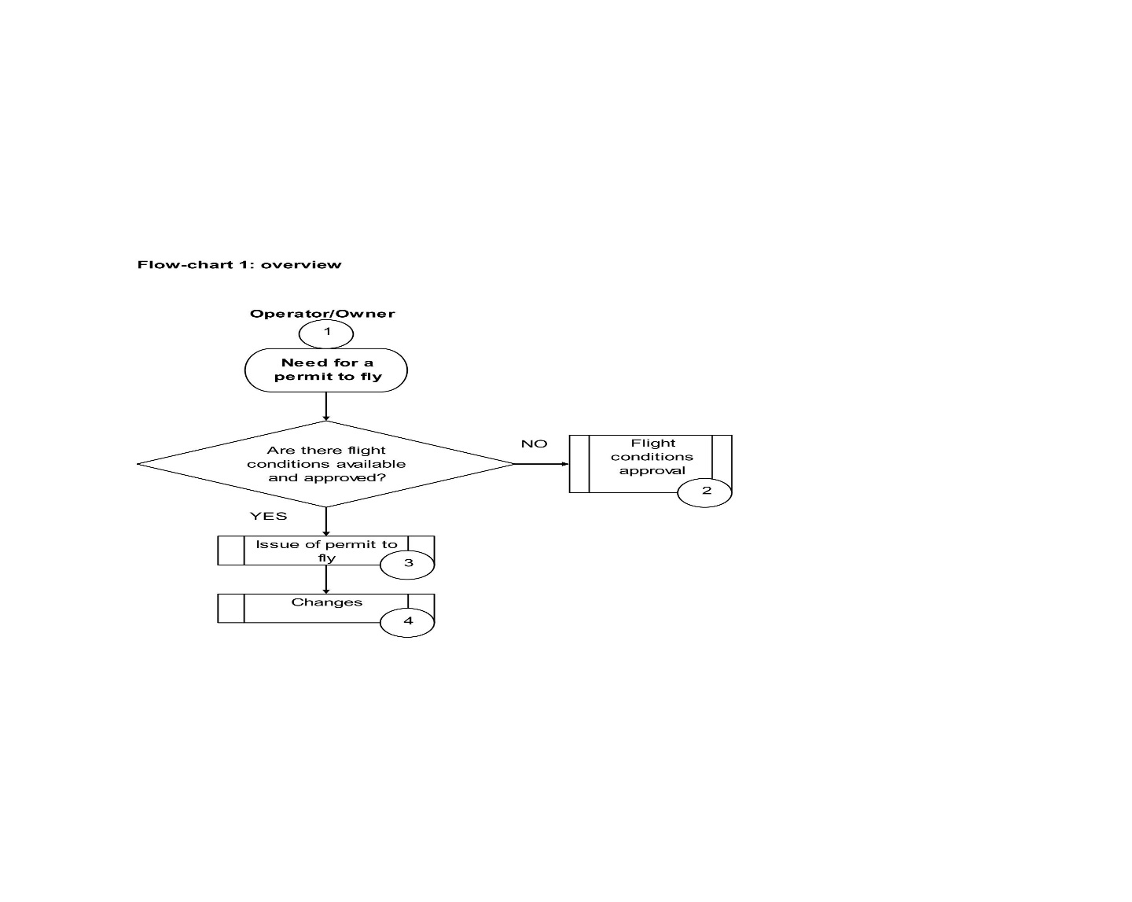

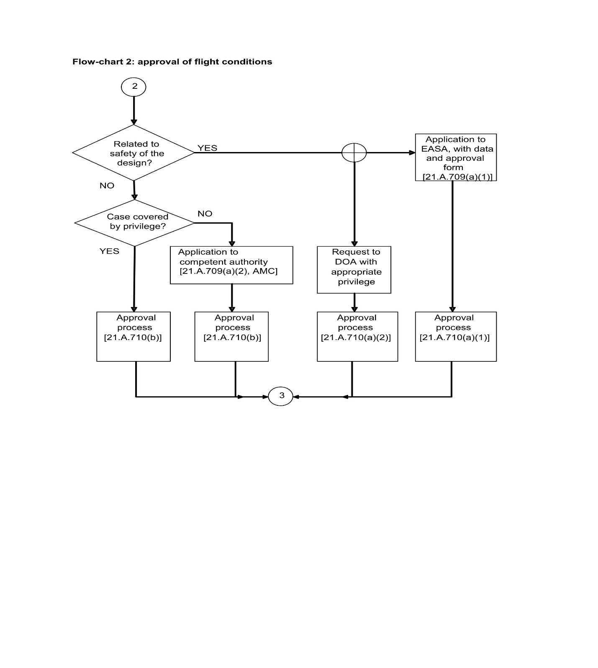

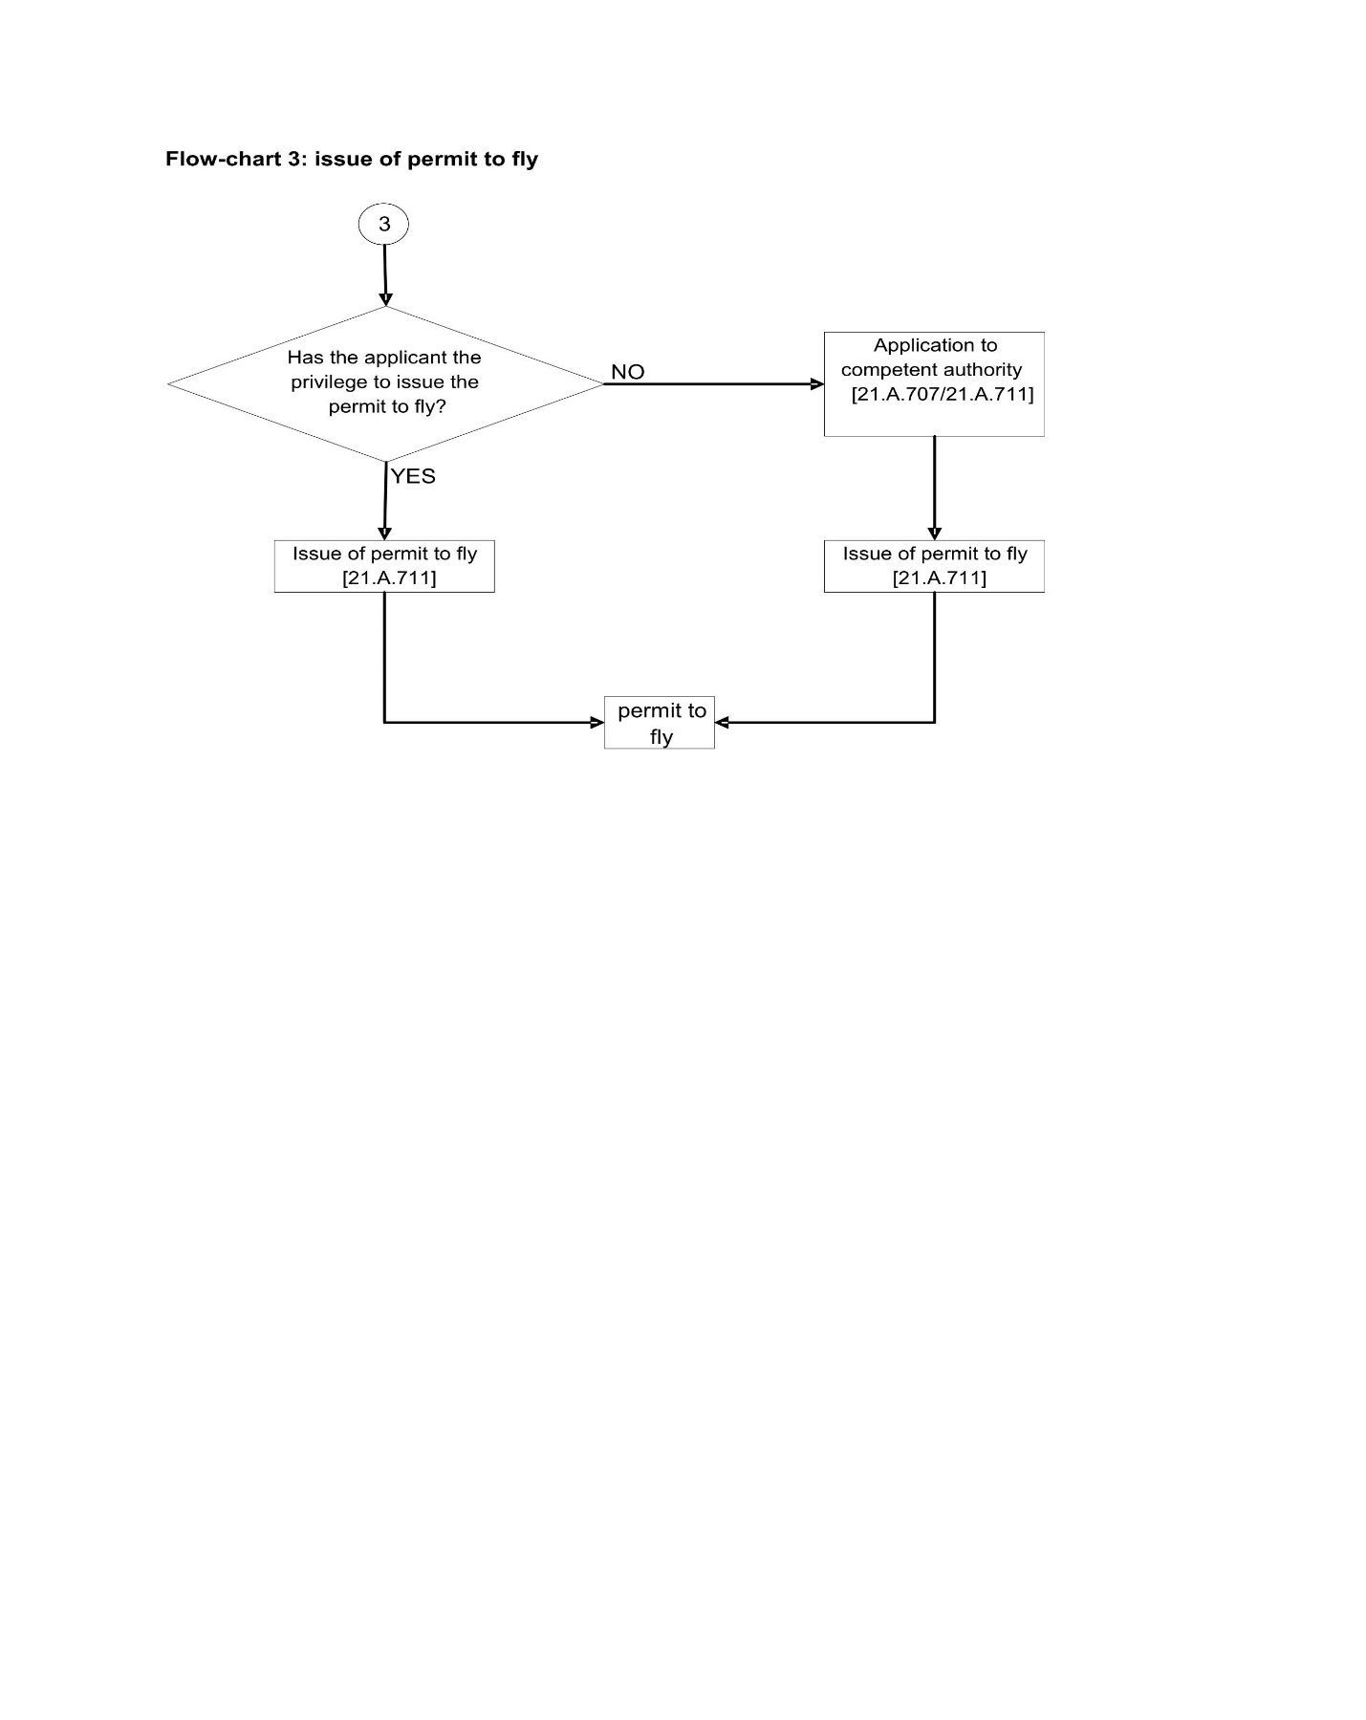

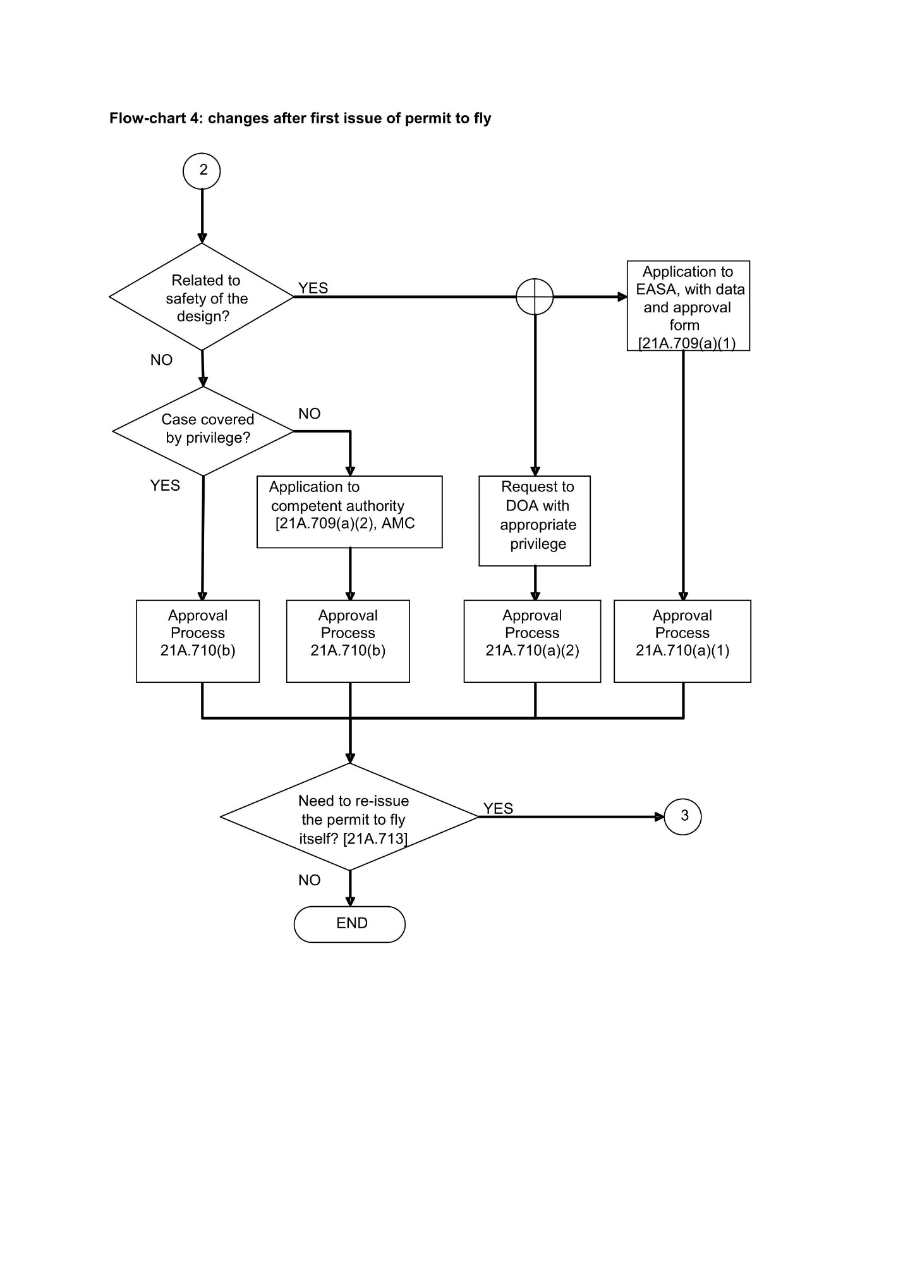
GM 21.A.701 (a) - Permit to fly when certificate of airworthiness or restricted certificate of airworthiness is not appropriate
A certificate of airworthiness or restricted category certificate of airworthiness may not be appropriate for an individual aircraft or aircraft type when it is not practicable to comply with the normal continued airworthiness requirements and the aircraft is to a design standard that is demonstrated to be capable of safe flight under defined conditions. Point 21.A.701 identifies cases where the issuance of a (restricted) certificate of airworthiness may not be possible or appropriate and this GM provides further information and typical examples for clarification where appropriate: -
Note: This list of examples is not exhaustive
- Development:
- testing of new aircraft or modifications
- testing of new concepts of airframe, engine, propeller and equipment;
- testing of new operating techniques;
- Demonstration of compliance with regulations or certification specifications:
- certification flight testing for type certification, supplemental type certificates, changes to type certificates or TSO authorisation;
- Design organisations or production organisations crew training:
- Flights for training of crew that will perform design or production flight testing before the design approval or Certificate of Airworthiness (C of A) can be issued.
- Production flight testing of new production aircraft:
- For establishing conformity with the approved design, typically this would be the same program for a number of similar aircraft;
- Flying aircraft under production between production facilities:
- green aircraft ferry for follow on final production.
- Flying the aircraft for customer acceptance:
- Before the aircraft is sold and/or registered.
- Delivering or exporting the aircraft:
- Before the aircraft is registered in the State where the C of A will be issued.
- Flying the aircraft for Authority acceptance:
- In the case of inspection flight test by the authority before the C of A is issued.
- Market survey, including customer’s crew training:
- Flights for the purpose of conducting market survey, sales demonstrations and customer crew training with non type-certificated aircraft or aircraft for which conformity has not yet been established or for non-registered a/c and before the Certificate of Airworthiness is issued.
- Exhibition and air show:
- Flying the aircraft to an exhibition or show and participating to the exhibition or show before the design approval is issued or before conformity with the approved design has been shown.
- Flying the aircraft to a location where maintenance or airworthiness review are to be performed, or to a place of storage:
- Ferry flights in cases where maintenance is not performed in accordance with approved programmes, where an AD has not been complied with where certain equipment outside the Master Minimum Equipment List (MMEL) is unserviceable or when the aircraft has sustained damage beyond the applicable limits.
- Flying an aircraft at a weight in excess of its maximum certificated take-off weight for flight beyond the normal range over water, or over land areas where adequate landing facilities or appropriate fuel is not available:
- Oversees ferry flights with additional fuel capacity.
- Record breaking, air racing or similar competition:
- Training flight and positioning flight for this purpose are included
- Flying aircraft meeting the applicable certification specifications before conformity to the environmental requirements has been found:
- Flying an aircraft which has been demonstrated to comply with all applicable certification specifications but not with environmental requirements.
- For non-commercial flying activity on individual non-complex aircraft or types for which a certificate of airworthiness or restricted certificate of airworthiness is not appropriate.
- For aircraft which cannot practically meet all applicable certification specifications, such as certain aircraft without TC-holder (‘generically termed orphan aircraft’) or aircraft which have been under national systems of Permit to Fly and have not been demonstrated to meet all applicable requirements. The option of a permit to fly for such an aircraft should only be used if a certificate of airworthiness or restricted certificate of airworthiness cannot be issued due to conditions which our outside the direct control of the aircraft owner, such as the absence of properly certified spare parts.
Note: The above listing is of cases when a permit to fly MAY be issued; it does not mean that in the described cases a permit to fly MUST be issued. If other legal means are available to allow the intended flight(s) they can also be used.
GM 21.A.701 - Scope
An aircraft registered outside the Member States and used for flight testing by an organisation which has its principle place of business in a Member State, remains under the authority of its state of registry. The Agency or an appropriately approved design organisation can provide, on request, technical assistance to the state of registry for the issue of a permit to fly, or equivalent authorisation, under the state of registry applicable regulations.
GM 21.A.703 - Applicant for a permit to fly
- The applicant for a permit to fly may be a person other than the registered owner of the aircraft. As the holder of this permit will be responsible for ensuring that all the conditions and limitations associated with the permit to fly are continuously satisfied, the applicant for the permit should be a person or organisation suitable for assuming these responsibilities. In particular, the organisations designing, modifying or maintaining the aircraft should normally be the holder of the associated permits to fly.
- An appropriately approved design organisation can apply for the approval of the flight conditions when using its privilege in accordance with 21.A.263(b)(1).
GM 21.A.705 - Competent authority
An aircraft registered in a Member State is under the responsibility of this Member State for continuing airworthiness aspects. Consequently, any permit to fly under Part 21 should be issued by that Member State including cases where the aircraft will fly in another State. The permit to fly contains all the conditions and restrictions to ensure safe flight but other airspace and operational rules remain the competence of the authority of the State where the flight will take place. The applicant should therefore also ensure compliance with the relevant regulations of that State.
GM 21.A.707 (b) - Application
ASSA-AC Form 21 (see AMC 21.B.520(b)) should be obtained from the competent authority.
GM 21.A.708 (b) (6) - Continuing airworthiness
In most cases a simple reference to existing maintenance requirements will suffice for aircraft that have a temporarily invalid C of A.
For other aircraft it will have to be proposed by the applicant as part of the flight conditions. For approved organisations they can be included in their procedures.
GM1 to 21.A.708 (c) - Safe flight
Safe flight normally means continued safe flight and landing but in some limited cases (e.g. higher risk flight testing) it can mean that the aircraft is able to fly in a manner that will primarily ensure the safety of overflown third parties, the flight crew and, if applicable other occupants.
This definition of ‘safe flight’ should not be interpreted as allowing a test pilot, equipped with a parachute and operating over a sparsely populated area, to set out on a test flight in the full knowledge that there is a high probability of losing the aircraft. The applicant should take reasonable care to minimise safety risks and to be satisfied that there is a reasonable probability that the aircraft will carry out the flight without damage or injury to the aircraft and its occupants or to other property or persons whether in the air or on the ground.
GM2 to 21.A.708 (c) - Substantiations
The substantiations should include analysis, calculations, tests or other means used to determine under which conditions or restrictions the aircraft can perform safely a flight.
GM3 to 21.A.708(c) - Operation of Overweight Aircraft
This GM provides information and guidance with respect to permit to fly for operating an aircraft in excess of its maximum certificated take-off weight, for flight beyond the normal range over water, or over land areas where adequate landing facilities or appropriate fuel is not available.
- GENERAL.
The excess weight that may be authorized for overweight operations should be limited to additional fuel, fuel carrying facilities, and navigational equipment necessary for the flight.
It is recommended that the applicant discuss the proposed flight with the TC holder of the aircraft to determine the availability of technical data on the installation of additional fuel carrying facilities and/or navigational equipment.
- CRITERIA USED TO DETERMINE THE SAFETY OF ADDITIONAL FACILITIES.
In evaluating the installation of additional facilities, the Agency or the design organisation must find that the changed aircraft is safe for operation. To assist in arriving at such a determination, the following questions are normally considered:
- Does the technical data include installation drawings, structural substantiating reports, weight, balance, new centre of gravity limits computations, and aircraft performance limitations in sufficient detail to allow a conformity inspection of the aircraft to be made?
- In what ways does the aircraft not comply with the applicable certification specifications?
- Are the fuel tanks vented to the outside? Are all areas in which tanks are located ventilated to reduce fire, explosion, and toxicity hazards?
- Are the tanks even when empty strong enough to withstand the differential pressure at maximum operating altitude for a pressurized aircraft?
- Have means been provided for determining the fuel quantity in each tank prior to flight?
- Are shutoff valves, accessible to the pilot, provided for each additional tank to disconnect these tanks from the main fuel system?
- Are the additional fuel tank filler connections designed to prevent spillage within the aircraft during servicing?
- Is the engine oil supply and cooling adequate for the extended weight and range?
- LIMITATIONS.
The following types of limitations may be necessary for safe operation of the aircraft:
- Revised operational airspeeds for use in the overweight condition.
- Increased pilot skill requirements.
- A prescribed sequence for using fuel from various tanks as necessary to keep the aircraft within its centre of gravity range.
- Notification to the control tower of the overweight take-off condition to permit use of a runway to minimize flight over congested areas.
- Avoidance of severe turbulence. If encountered, the aircraft should be inspected for damage as soon as possible.
EXAMPLE of operating limitations which may be prescribed as part of the permit to fly:
Aircraft type: xxxxxx Model: yyyy
Limitations:
- Maximum weight must not exceed 8 150 pounds.
- Maximum quantity of fuel carried in auxiliary tanks must not exceed 106 gallons in fwd tank, 164 gallons in centre tank, and 45 gallons in aft tank.
- Centre of gravity limits must not exceed (fwd) +116.8 and (aft) +124.6.
- Aerobatics are prohibited.
- Use of autopilot while in overweight condition is prohibited.
- Weather conditions with moderate to severe turbulence should be avoided.
- When an overweight landing is made or the aircraft has been flown through moderate or severe turbulence while in an overweight condition, the aircraft must be inspected for damage after landing. The inspections performed and the findings must be entered in the aircraft log. The pilot must determine, before the next take-off, that the aircraft is airworthy.
- When operated in the overweight condition, the cruising speed (Vc) shall not exceed 185 m.p.h. and the maximum speed (Vne) shall not exceed 205 m.p.h.
- Operation in the overweight condition must be conducted to avoid areas having heavy air traffic, to avoid cities, towns, villages, and congested areas, or any other areas where such flights might create hazardous exposure to person or property on the ground.
GM 21.A.708 (d) - Control of aircraft configuration
The applicant should establish a method for the control of any change or repair made to the aircraft, for changes and repairs that do not invalidate the conditions established for the permit to fly.
All other changes should be approved in accordance with 21.A.713 and when necessary a new permit to fly should be issued in accordance with 21.A.711.
AMC 21.A.709 (b) - Submission of documentation supporting the establishment of flight conditions
Together with the application, the documentation required by 21.A.709(b) must be submitted with the approval form (ASSA-AC Form 18B) defined below, completed with all relevant information. If the complete set of data is not available at the time of application, the missing elements can be provided later. In such cases, the approval form must be provided only when all data are available, to allow the applicant to make the statement required in box 9 of the form.

FLIGHT CONDITIONS FOR A PERMIT TO FLY – APPROVAL FORM
- Applicant  [Name of organisation providing the flight conditions and associated substantiations] | - Approval form No:  Issue:  [Number and issue, for traceability purpose]
- Aircraft manufacturer/type | - Serial number(s)
- Purpose
[Purpose in accordance with 21.A.701(a)]
- Aircraft configuration
The above aircraft for which a permit to fly is requested is defined in [add reference to the document(s) identifying the configuration of the aircraft]
[For change(s) affecting the initial approval form: description of change(s). This form must be re-issued]
- Substantiations
[References to the document(s) justifying that the aircraft (as described in 6.) can perform the intended flight(s) safely under the defined conditions or restrictions.]
[For change(s) affecting the initial approval form: reference(s) to additional substantiation(s). This form must be re-issued]
- Conditions/Restrictions
The above aircraft must be used with the following conditions or restrictions:
[Details of these conditions/restrictions, or reference to relevant document, including specific maintenance instructions and conditions to perform these instructions]
- Statement
The flight conditions have been established and justified in accordance with 21.A.708.
The aircraft as defined in block 6 above has no features and characteristics making it unsafe for the intended operation under the identified conditions and restrictions.
[when approved under a privilege of an approved organisation]
- Approved under [ORGANISATION APPROVAL NUMBER]’
- Date of issue | - Name and signature  [Authorised signatory]
when not approved under a privilege of an approved organisation]
- Approval and date
[the appropriate approval: ASSA-AC, competent authority]
ASSA-AC Form 18B Issue 3
When the flight conditions are approved under a privilege, this form should be used by the approved organisation to document the approval.
GM 21.A.710 Approval of flight conditions
- The approval of flight conditions is related to the safety of the design, when:
- the aircraft does not conform to an approved design; or
- an Airworthiness Limitation, a Certification Maintenance Requirement or an Airworthiness Directive has not been complied with; or
- the intended flight(s) are outside the approved envelope;
- the permit to fly is issued for the purpose of 21.A.701(a)(15).
- Examples when the approval of flight conditions is not related to the safety of the design are:
- production flight testing for the purpose of conformity establishment;
- delivery / export flight of a new aircraft the design of which is approved;
- demonstrating continuing conformity with the standard previously accepted by the Agency for the aircraft or type of aircraft to qualify or re-qualify for a (restricted) certificate of airworthiness.
GM 21.A.711 (e) - Additional conditions and restrictions
The conditions and restrictions prescribed by the competent authority may include airspace restrictions to make the conditions approved under 21.A.710 more concrete, or conditions outside the scope of the ones mentioned in 21.A.708(b) such as a radio station license.
GM 21.A.713 - Changes
Changes to the conditions or associated substantiations that are approved but do not affect the text on the permit to fly do not require issuance of a new permit to fly.
In case a new application is necessary, the substantiation for approval of the flight conditions only needs to address the change.
GM 21.A.719 - Transfer of a permit to fly
Except for permits to fly issued under 21.A.701(a)(15), like aircraft without TC holder, a permit to fly is issued based upon the applicant’s declaration of many aspects of the proposed flight or flights, some of which are specific to the applicant. Accordingly, the basis upon which a permit to fly has been issued necessarily is no longer fully in place when the holder of a permit to fly changes, ownership changes, and/or there is a change of register. Such changes necessitate a new application under 21.A.707

SUBPART Q – IDENTIFICATION OF PRODUCTS, PARTS AND APPLIANCES
Réservé

SECTION B — PROCEDURES FOR COMPETENT AUTHORITIES
SUBPART A – GENERAL
GM 21B.20 - Responsibility for implementation
Each certificate or approval in accordance with Part 21 Section A Subparts F, G, H and I will normally be issued and controlled by the competent authority of the Member State in whose country the applicant or holder is located. Therefore, to ensure consistency between the competent authorities of the Member States in issuing certificates and approvals, implementation of Part 21 should be based on the following three principles:
- The establishment and maintenance of an effective organisation and corresponding processes by all competent authorities.
- The operation of all competent authorities in accordance with Part 21 and its certification specifications (CS).
- A standardisation process established and operated by the Agency to access the standard achieved, and to provide timely advice and guidance to the competent authorities of the Member States.
As a result the responsibility for implementation comprises of the two main objectives:
- to ensure that certificates and approvals are only granted to applicants that comply with the requirements of Part 21; and
- to ensure sufficient visibility of the processes to give the Agency and the other Member States the necessary confidence in the certificates or approvals granted.
GM 21B.25(a) - Organisation
The competent authority designated by each Member State should have an organisation in such a way that
- there is specific and effective management authority in the conduct of all relevant activities
- the functions and processes described in Part 21 and its CS and GM may be properly implemented
- the competent authority of the Member State policy, organisation and operating procedures for the implementation of Part 21 are properly documented and applied
- all competent authority of the Member State personnel involved in the related activities are provided with training where necessary
- specific and effective provision is made for the communication and interface as necessary with the Agency and the competent authorities of the Member States
- all functions related to the implementation of Part 21 are adequately described and shown (Standardisation)
A general policy in respect of Part 21 activities should be developed, sponsored and implemented by the manager at the highest appropriate level, for example the top of the functional area of the competent authority of the Member State that is responsible for the related matters.
Appropriate steps should be taken to ensure that the policy is known and understood by all staff involved, and all necessary steps should be taken to implement and maintain the policy
Whilst satisfying also additional national regulatory responsibilities, the general policy should in particular take into account:
- the provisions of the Basic Regulation
- the provisions of Part 21 and its CS and GM
- the needs of industry
- the needs of the Agency and of the competent authorities of the Member States.
The policy should define specific objectives for key elements of the organisation and processes for implementation of related Part 21 activities, including the corresponding control procedures and the measurement of the achieved standard.
GM 21B.25 (b) - Resources
The organisation for related Part 21 activities should be clearly defined within the general organisation of the competent authority of the Member State, with the hierarchical and functional links, and the names of the senior staff. Although final responsibility should be placed at the top of the functional area that is responsible for the related Part 21 activities as a whole, all subordinate levels of management should be suitably resourced and empowered to fulfil their delegated tasks.
The definition of an organisation for the implementation of related Part 21 activities should include the specification of:
- a manager responsible for the specific Part 21 activity acting as internal and external focal point. The responsibility is best placed with the manager who is in control of the day-to-day functions concerning the specific Part 21 activity, although he may delegate specific tasks to other individuals;
- individual or group responsibilities, duties and associated reporting lines;
- the resources, human and material;
- the documented procedures to be operated in respect of the relevant Part 21 activities.
The various tasks and responsibilities of the personnel involved in the related Part 21 activities should be clearly identified. The authority attached to the responsibilities should be enough to ensure that the activities will be performed correctly.
These responsibilities include among others:
- the management of the organisation
- the management of investigation teams
- the team leadership/membership
- the investigation and surveillance activities
- the administrative management of certificates and approvals including record keeping
- the external and internal interface activities including feedback to the Agency
- the control and distribution of documentation
The definition of the organisation should include means to ensure continued effectivity of the organisation. The means should provide for a regular assessment of the organisation and its related activities as well as a feedback system for the follow up of necessary corrective actions (e.g., through the implementation of a quality system, internal audit system, etc.).
GM 21B.25 (c) - Qualification and training
The competent authority of the Member State should ensure appropriate and adequate training of its personnel to meet the standard that is considered by the Agency necessary to perform the work. Arrangements should be made for initial and continuation training as required.
It is understood that the basic competence of the competent authority of the Member State staff is a matter of recruitment and normal management functions in selection of staff for particular duties. Moreover, it is understood that the competent authority of the Member State provides training in the basic skills as required for those duties.
However, to avoid differences in understanding and interpretation, it is considered important that all personnel involved in Part 21 activities should be provided with further training specifically related to the relevant Part 21 activity up to the common Agency standard.
The competent authority of the Member State should provide training through its own training organisation with qualified trainers or through another qualified training source (e.g., training provided by other competent authorities, the Agency or qualified entities).
AMC 21B.30 (a) - Documented procedures
The various elements of the organisation for the related Part 21 activities must be documented in order to establish a reference source for the establishment and maintenance of this organisation. The documented procedures must be established in a way that it will facilitate its use. They must be clearly identified, kept up-to-date and made readily available to all the personnel involved in the relevant activities.
The documented procedures must cover, as a minimum, the following aspects:
- policy and objectives,
- organisation structure,
- responsibilities and attached authority,
- procedures and processes,
- internal and external interfaces,
- internal control procedures,
- training of personnel,
- cross references to associated documents,
- assistance from other competent authorities or the Agency (where required)
Except for smaller competent authorities, it is likely that the information is held in more than one document or series of documents, and suitable cross-reference information must be provided. For example, organisational structure and job descriptions are not usually in the same documentation as the detailed working procedures. In such cases it is recommended that the documented procedures include an index of cross-references to all such other related information, and the related documentation must be readily available when required.
AMC 21B.35 (a) - Changes
Standardisation is based on the assessment of the organisation and procedures of the competent authorities of the Member States and their implementation and suitability by the Agency. Consequently, a significant change in the competent authority of the Member State organisation and documented procedures validated by the Agency needs a reassessment to maintain the confidence in the standardisation process.
Examples of significant changes include changes in the organisation hierarchy, decision making levels, number and qualification of personnel, etc.
The competent authority of the Member State must notify any of these changes to the Agency and must be prepared to provide any further explanation/information requested by the Agency. The Agency may decide to review the documented organisation and procedures of the competent authority of the Member State and request any clarification or changes. This might also apply when a change in the regulations takes place and the Agency decides that a specific assessment/monitoring of the competent authorities related to that change is necessary.
GM 21B.40 - Principles for the resolution of disputes
It is essential for the efficient accomplishment of the competent authority of the Member State activities related to Part 21 that all decisions regarding the resolution of disputes are taken at as low a level as possible. In addition the documented procedures for the resolution of disputes should clearly identify the chain of escalation.
GM1 to 21B.45 - Co-ordination with other related activities
The purpose of co-ordination with other related activities is to
- harmonize the effects of various approval and certification teams especially when dealing with one organisation / applicant to prevent conflicts of conclusions
- ensure efficient flow of information between the various approval and certification teams to facilitate the execution of their duties
- optimise the use of the Agency and the competent authorities resources to minimise disruption and cost.
Therefore, for a given organisation / applicant the responsible person(s) of the Agency or competent authorites of the Member State should arrange for exchange of information with, and provide necessary assistance, as appropriate, to the relevant competent authority of the Member State or Agency teams or staff - e.g.:
- the appropriate certification teams;
- the design organisation approval team;
- the production organisation approval team;
- the maintenance organisation approval team; or
- other approval or certification teams as appropriate.
GM2 to 21B.45 - Co-ordination
An exchange of information should especially take place in accordance with Article 10 of the Basic Regulation:
- an immediate reaction of a competent authority of the Member State to a safety problem
- granting of exemptions by the competent authority of the Member State from the substantive requirements of the Basic Regulation and its implementing rules (for a period of more than two months or when the exemptions become repetitive)
- granting of approvals on an equivalent level of protection by the competent authority of the Member State by derogation from the Part 21 requirements
GM3 to 21B.45 - Reporting - Information relevant to registers established by the Agency
When so requested by the Agency, the competent authority of the Member State should notify any certificate or approval issued, changed or revoked including details of the scope of that certificate or approval to the Agency for inclusion in a central register managed by the Agency.
GM1 to 21B.50 - Standardisation findings by the Agency
The competent authority of the Member State should respond in a positive manner to any findings identified during the standardisation activities by the Agency and should make any recommended changes in its interpretation of Part 21, its procedures or its organisation.
For standardisation purposes, the competent authority of the Member State should be prepared to accept participation of representatives of the Agency during activities related to Part 21.
GM2 to 21B.50 - Standardisation - Means established by the Agency
The Agency may implement administrative and procedural means to ensure a uniform approach for the implementation of Part 21 throughout the Member States. This may require the individual Member States to adjust their procedures and processes (e.g. a standardised numbering system for approvals) accordingly.
GM 21B.55 - Record keeping for design approvals transferred to the Agency
Record keeping related to design approvals, for which the responsibility is transferred to the Agency, will remain initially with the competent authority of the Member State that has granted the approvals, at the disposal of the Agency. This GM specifies the administrative documents to be kept for the various kinds of design approvals. It does not repeat the requirements put on holders of design approvals to keep records (ref. 21A.55, 21A.105, 21A.118A(a)(1), 21A.447, 21A.605)
- Type-certificate
        - Copy of the type-certificate
        - Copy of the type-certificate data sheet
        - Environmental protection approval data
        - Documents defining the type-certification basis including information to justify special conditions, equivalent safety findings and exemptions (Certification Review Items or equivalent)
        - List of approved modifications,
        - List of competent authorities approved publications (Flight Manual, Repair Manual, Airworthiness Limitations, Certification Maintenance Requirements)
        - Airworthiness directives
        - Master Minimum Equipment List
        - Maintenance Review Board Report
- Supplemental type certificate
    - Copy of supplemental type certificate
    - Environmental protection approval data
    - Documents defining the certification basis including information to justify special conditions, equivalent safety findings and exemptions (Certification Review Items or equivalent)
    - List of competent authorities approved documents
    - Airworthiness directives
- TSO Authorisation
      - Copy of TSO authorisation letter,
      - Copy of Declaration of Design and Performance
      - Statement of compliance with applicable standards
      - Airworthiness directives
- Other part or appliance approvals
    - Copy of approval letter,
    - Copy of Declaration of Design and Performance or equivalent
    - Statement of compliance with applicable standards
    - Airworthiness Directives

- Changes from non TC or STC holders
  - Modification approval sheet, or equivalent document
  - Documents required by 21A.105, or equivalent national requirement
Note: not applicable to minor design changes approved under a DOA privilege, for which record keeping is under the DOA holder responsibility.
- Repair design approvals
  - Repair approval sheet
  - Documents listed in 21A.447, or equivalent national requirement
Note: not applicable to repair design approved under a DOA privilege, for which record keeping is under the DOA holder responsibility

SUBPART B – TYPE-CERTIFICATES AND RESTRICTED TYPE-CERTIFICATES
Réservé

SUBPART C – NOT APPLICABLE

SUBPART D – CHANGES TO TYPE-CERTIFICATES AND RESTRICTED TYPE-CERTIFICATES
Réservé

SUBPART E – SUPPLEMENTAL TYPE-CERTIFICATES
Réservé

SUBPART F - PRODUCTION WITHOUT PRODUCTION ORGANISATION APPROVAL
Réservé

SUBPART G- PRODUCTION ORGANISATION APPROVAL
Réservé

SUBPART H - AIRWORTHINESS CERTIFICATES AND RESTRICTED CERTIFICATES OF AIRWORTHINESS
GM 21B.320 (b) (6) - Investigation
- Determination of necessary conditions, restrictions and/or limitations on the airworthiness certificate issued by a Member State
The competent authority of the Member State of registry may issue under its own legislation a document to list and identify all necessary conditions, restrictions and limitations that result from the investigation by the Agency and/or from the legislation of the competent authority of the Member State of registry. This document could take the form of an addendum to the approved Flight Manual or Operating instruction or comparable document and should be referenced in Block 5 (limitations/remarks) of the appropriate Certificate of Airworthiness.
GM 21B.325 (a) - Airworthiness Certificates
- Completion of the certificate of airworthiness by a Member State
Block 5: Insert restrictions developed in accordance with Part 21, including any reference to limitations as indicated in GM 21B.320(b)(6).
2 Completion of the restricted certificate of airworthiness by a Member State
Block 5: Insert restrictions developed in accordance with Part 21, including any reference to limitations as indicated in GM 21B.320(b)(6).
3 Completion of the permit to fly by a Member State
Block 4: Insert purpose of flight in accordance with Article 5(4)(e)(ii) first indent of the Basic Regulation.
Block 5: Insert restrictions in accordance with Article 5(4)(e)(ii) second and third indent of the Basic Regulation.
GM 21B.325 (b) - Completion of the Airworthiness Review Certificate by a Member State
In accordance with the applicable continuing airworthiness requirements a certificate of airworthiness is valid only if a valid airworthiness review certificate is attached to it. For new aircraft, the Competent Authority will issue the airworthiness review certificate when issuing the certificate of airworthiness

SUBPART I - NOISE CERTIFICATES
GM 21.B.425 (a) - Noise certificates
- Completion of the noise certificate by a Member State
  - Completion instructions
Block 1 State of registry
The name of the State issuing the noise certificate. This item should match the corresponding information on the certificate of registration and certificate of airworthiness.
Block 2 Noise certificate
The title of the ASSA-AC Form 45 is ‘Noise Certificate’
Block 3 Document No
A unique number, issued by the State of registry that identifies this particular document in their administration. Such a number will facilitate any enquiries with respect to the document.
Block 4 Registration marks
The nationality or common mark and registration marks as issued by the State of registry in accordance with Annex 7 to the Chicago Convention2. This item should match the corresponding information on the certificate of registration and certificate of airworthiness.
Block 5 Manufacturer and manufacturer’s designation of aircraft
The type and model of the subject aircraft. This item should match the corresponding information on the certificate of registration and certificate of airworthiness.
Block 6 Aircraft serial No
The aircraft serial number as given by the manufacturer of the aircraft. This item should match the corresponding information on the certificate of registration and certificate of airworthiness.
Block 7 Engine
The designation of the installed engine(s) for identification and verification of the aircraft configuration. It should contain the type and model of the subject engine(s). The designation should be in accordance with the type certificate or supplemental type certificate for the subject engine(s).
Block 8 Propeller
The designation of the installed propeller(s) for identification and verification of the aircraft configuration. It should contain the type and model of the subject propeller(s). The designation should be in accordance with the type certificate or supplemental type certificate for the subject propeller(s). This item is included only in noise certification documentation for propeller driven aeroplanes.
Block 9 Maximum take-off mass (kg)
The maximum take-off mass associated with the certificated noise levels of the aircraft in kilograms. The unit (kg) should be specified explicitly in order to avoid misunderstanding. If the primary unit of mass for the State of manufacture of the aircraft is different from kilograms, the conversion factor used should be in accordance with Annex 5 to the Chicago Convention.
Block 10 Maximum landing mass (kg)
The maximum landing mass associated with the certificated noise levels of the aircraft in kilograms. The unit (kg) should be specified explicitly in order to avoid misunderstanding. If the primary unit of mass for the State of manufacture of the aircraft is different form kilograms, the conversion factor used should be in accordance with Annex 5 to the Chicago Convention. This item will only be included in the noise certification documentation for noise certificates issued under Chapter 2, 3, 4, 5 and 12.
Block 11 Noise certification standard
The Chapter to which the subject aircraft is noise certificated. For chapters 2, 8, 10 and 11, the section specifying the noise limits should also be included.
Block 12 Additional modifications incorporated for the purpose of compliance with the applicable noise certification standards
This item should contain as a minimum all additional modifications to the basic aircraft as defined by Blocks 5, 7 and 8 that are essential in order to meet the requirements of this Annex to which the aircraft is certificated as given under Block 11. Other modifications that are not essential to meet the stated chapter but are needed to attain the certificated noise levels as given may also be included at the discretion of the certificating authority. The additional modifications should be given using unambiguous references, such as supplemental type certificate (STC) numbers, unique part numbers or type/model designators given by the manufacturer of the modification.
Block 13 Lateral/full-power noise level
The lateral/full-power noise level as defined in the relevant Chapter. It should specify the unit (e.g. EPNdB (unit of the effective perceived noise level)) of the noise level and the noise level should be stated to the nearest tenth of a decibel (dB). This item is included only in noise certification documentation for aircraft certificated to Chapters 2, 3, 4, 5 and 12.

Block 14 Approach noise level
The approach noise level as defined in the relevant chapter. It should specify the unit (e.g. EPNdB) of the noise level and the noise level should be stated to the nearest tenth of a dB. This item is included only in noise certification documentation for aircraft certificated to Chapters 2, 3, 4, 5, 8 and 12.
Block 15 Flyover noise level
The flyover noise level as defined in the relevant chapter. It should specify the unit (e.g. EPNdB) of the noise level and the noise level should be stated to the nearest tenth of a dB. This item is included only in noise certification documentation for aircraft certificated to Chapters 2, 3, 4, 5 and 12.
Block 16 Overflight noise level
The overflight noise level as defined in the relevant chapter. It should specify the unit (e.g. EPNdB or dB(A) (unit of the A-weighted noise level)) of the noise level and the noise level should be stated to the nearest tenth of a dB. This item is included only in noise certification documentation for aircraft certificated to Chapters 6, 8 and 11.
Block 17 The take-off noise level
The take-off noise level as defined in the relevant chapter. It should specify the unit (e.g. EPNdB or dB(A)) of the noise level and the noise level should be stated to the nearest tenth of a dB. This item is included only in noise certification documentation for aircraft certificated to Chapters 8 and 10.
Block 18 Statement of compliance, including reference to Annex 16 to the Chicago Convention, Volume I
The statement is provided in ASSA-AC Form 45.
Block 19 Date of issue
The date on which the document was issued.
Block 20 Signature
The signature of the officer issuing the noise certificate. Other items may be added such as seal, stamp etc.
Additional information:
- Logo and name of the issuing authority
In order to facilitate recognition the logo or symbol and the name of the issuing authority may be added in the box ‘For use by the State of registry’.
- Language
States issuing their noise certification documentation in a language other than English should provide an English translation.
SUBPART J – DESIGN ORGANISATION APPROVAL

SUBPART K – PARTS AND APPLIANCES
Réservé

SUBPART L – NOT APPLICABLE

SUBPART M – REPAIRS
Réservé

SUBPART N – NOT APPLICABLE
Réservé

SUBPART O – TECHNICAL STANDARD ORDER AUTHORISATIONS
Réservé

SUBPART P – PERMIT TO FLY
AMC 21.B.520 (b) - Application for a permit to fly
The competent authority must receive an application for permit to fly in a form and manner established by that authority, e.g. on ASSA-AC Form 21 (see below) completed by the applicant.
Application for Part 21 Permit to Fly
- Applicant: | [Name of applicant]
- Aircraft nationality and identification marks:
- Aircraft owner
- Aircraft manufacturer/type |  | - Serial number
- Purpose of flight
[Use terminology of 21.A.701(a) and add any additional information for accurate description of the purpose, e.g. place, itinerary, duration…]
[For an application due to a change of purpose (ref. 21.A.713): reference to initial request and description of new purpose]
- Expected target date(s) for the flight(s) and duration
- Aircraft configuration as relevant for the permit to fly
  - The above aircraft for which a permit to fly is requested is defined in [add reference to the document(s) identifying the configuration of the aircraft. Same as required in AMC 21.A21.A.263(c)(6) or AMC 21A.21.A.709(b) application approval form 18A or 18B, box 6]
  - 8.2 The aircraft is in the following situation related to its maintenance schedule:
[Describe status]
- Approval of flight conditions [if not available at the time of application, indicate reference of request for approval]
[Reference to:
- ASSA-AC approval, if flight conditions are approved by ASSA-AC; or
- DOA approval form (see AMC 21.A.263(c)(6)), if approved under DOA privilege; or
- 3. Competent authority approval.
- Date: |  | - Name and signature:  [Authorised signatory]
ASSA-AC Form 21

SUBPART Q – IDENTIFICATION OF PRODUCTS, PARTS AND APPLIANCES
Réservé

